Acceptance Testing
UAT Execution & Report Submission

Date | 01 October 2026
Team ID | SWTID-2026-2085
Project Name | Import data using transform maps(spreadsheet)
Maximum Mark | 4 marks

- Purpose of Document
The purpose of this document is to briefly explain the test coverage and open issues of the Import Data Using Transform Maps (Spreadsheet) functionality at the time of the release to User Acceptance Testing (UAT).

- Defect Analysis
This report shows the number of resolved or closed bugs at each severity level, and how they were resolved
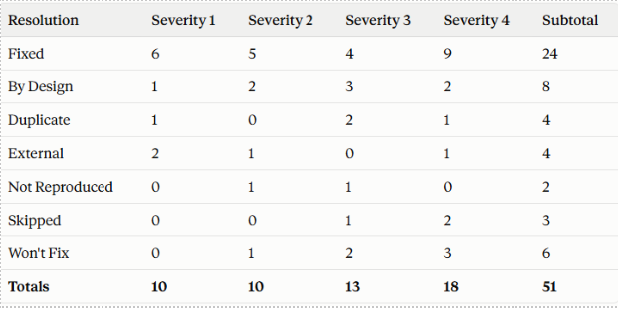

3.Test Case Analysis
This report shows the number of test cases that have passed, failed, and untested

